CS 423 Knapsack Exercise

* Given 5 items with weights and values as follows: w1=1, w2=2, w3=3, w4=2, w5=5 and v1=10, v2= 20, v3=40, v4=20, v5=50 total capacity of knapsack W = 10

|  |  |  |  |  |  |  |  |  |  |  |  |
| --- | --- | --- | --- | --- | --- | --- | --- | --- | --- | --- | --- |
| i\w | 0 | 1 | 2 | 3 | 4 | 5 | 6 | 7 | 8 | 9 | 10 |
| 0 | 0 | 0 | 0 | 0 | 0 | 0 | 0 | 0 | 0 | 0 | 0 |
| 1w1=1  v1=10 | **0** | 10 | 10 | 10 | 10 | 10 | 10 | 10 | 10 | 10 | 10 |
| 2 w2=2  V2=20 | 0 | 10 | **20** | 30 | 30 | 30 | 30 | 30 | 30 | 30 | 30 |
| 3 w3=3  V2=40 | 0 | 10 | 20 | 40 | 50 | **60** | 70 | 70 | 70 | 70 | 70 |
| 4  W4=2  V2=20 | 0 | 10 | 20 | 40 | 50 | **60** | 70 | 80 | 90 | 90 | 90 |
| 5  W5=5  V2=50 | 0 | 10 | 20 | 40 | 50 | 60 | 70 | 80 | 90 | 100 | **110** |

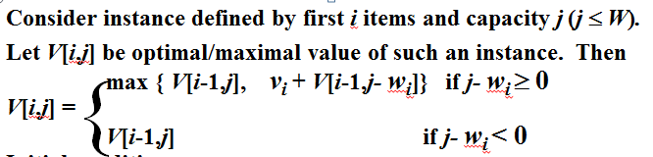

**ITEMS IN KNAPSACK : 5, 3, 2 WITH WEIGHT 10 AND VALUE 110**